**Documentation**

1. I started out by following the basic steps of creating a html document by using typing out html into the new atom project and pressing tab to auto complete it.  
   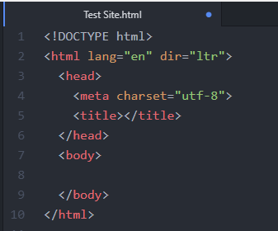
2. I then entered in a title which will show up on the browsers tab by inserting   
   HTML Testing | Samuel into the <title> angle brace.
3. I decided that the default favicon on the browser tab was not good enough so I found an online favicon creation tool which allowed me to create my own pixel style icon which I can save and embed into a HTML page.  
   Link: <https://www.favicon.cc/>   
   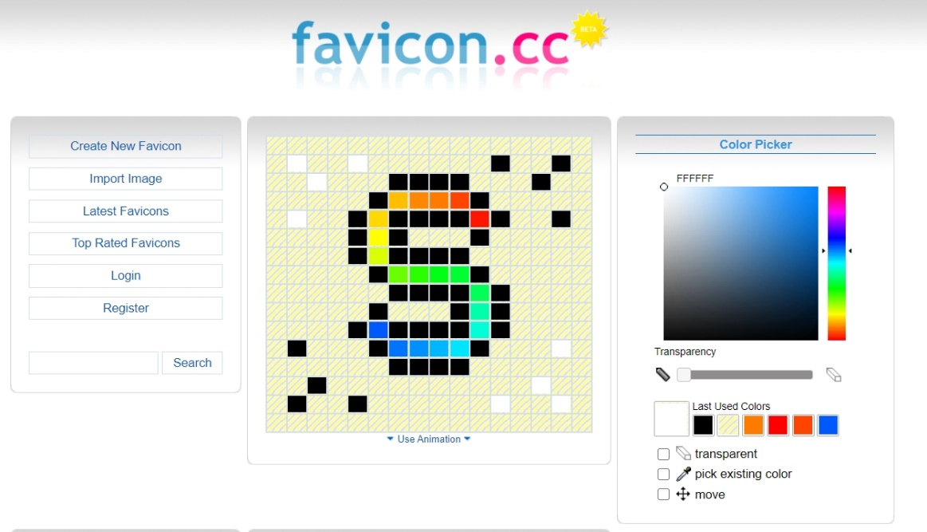
4. I then tried typing in the word favicon into atom hoping it would be a valid for auto completion. As it was a valid autocomplete option, I tabbed it in to get a new line of code within the <head> </head> section. I then changed .ico to say custom_favicon.ico.



I also made sure all my files were organised and in the relevant folders. I created two folders for both images and videos and made sure my favicons were in the root directory of my HTML file.

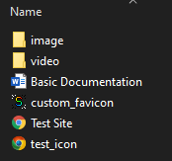

1. To practice using the <body></body> function I made multiples lines of code which give demonstrations of each of the headings. On the website this displays text for each heading.

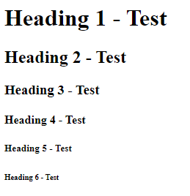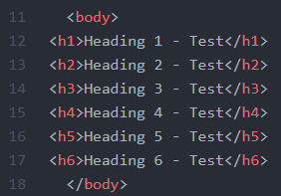

1. I then added a meta tag to make the web page more mobile friendly as recommended to do so in one of the videos. I followed along adding the code line as shown below.

